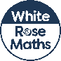
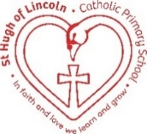
St Hugh of Lincoln Catholic Primary School - Reception Knowledge Organiser Autumn 2
Maths Topic: Light and Dark! 3 (1 week)
Key information, Vocabulary and Questions:
Shapes with 4 sides:  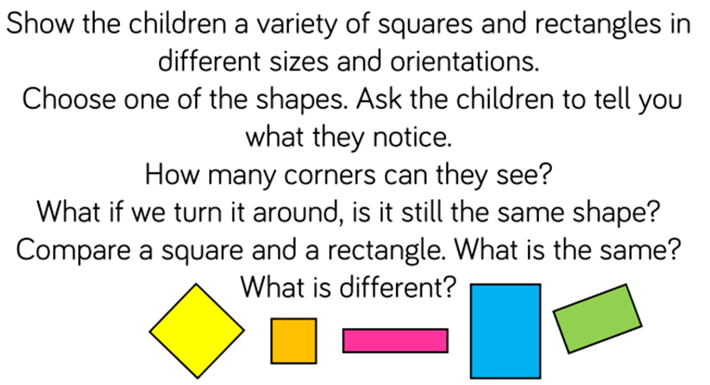  A square is a special kind of rectangle with 4 equal sides – this means that all the sides are the same length. | Activities to support learning at home:  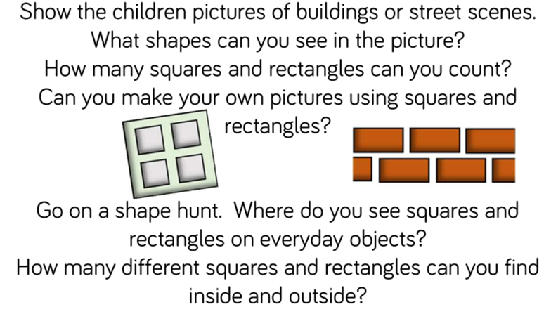  - Carefully open up and flatten some cardboard boxes/packaging – what squares and/or rectangles can you see?  - Use playdough to make squares and rectangles – keep discussing the sides and naming the shapes.  - Use pictures or squares and rectangles to make repeating patterns  - Explore folding paper in different ways, Open it out to see what shapes have been made by the folds.

