


St Hugh of Lincoln Catholic Primary School - Reception Knowledge Organiser Autumn 2
Maths Topic: Light and Dark! 2 (1 week)
Key information, Vocabulary and Questions:
1 more and 1 less:  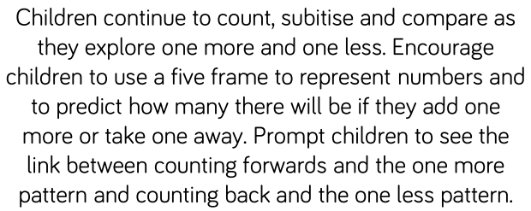  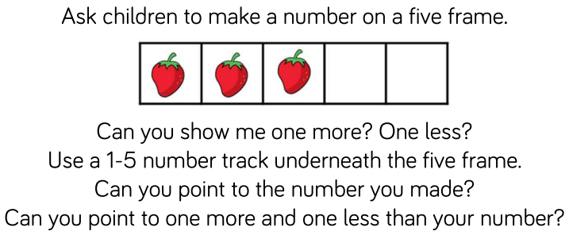  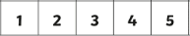 | Activities to support learning at home:  - Continue to sing and explore counting songs and rhymes e.g. Five Little Ducks Went Swimming One Day, Five Currant Buns in a Baker’s Shop, Five Little Speckled Frogs etc. Encourage the children use a 5 frame to show how the quantity changes by 1 more or 1 less each time.  - Read the traditional tales, The Enormous Turnip and The Gingerbread Man. Talk about the counting pattern where 1 more character joins in to help pull the turnip/chase the Gingerbread man. Encourage the children to use a 5 frame to show this as the stories are being read.  - Say a number 1-5 to the children and ask them to show you that number on their fingers. Then ask them to show you 1 more/1 less.  - Use blocks to make a tower. Ask the children to make a tower with 1 more/1 less.

