

St Hugh of Lincoln Catholic Primary School - Reception Knowledge Organiser Autumn 2
Maths Topic: Light and Dark! (1 week)
Key information, Vocabulary and Questions:
The numbers 4 and 5:  Children will continue to count on and back to 4 and 5. They can make their own collection of objects to 4 and 5. They will subitise and match the number names, numerals and quantities and are able to say which sets have more and which have fewer items. When counting, they continue to learn that the final number they say names the quantity of the set. They use their own mark-making to represent numbers to 4 and 5. They show up to 5 objects on a five frame and understand that if the frame is full then there are 5.  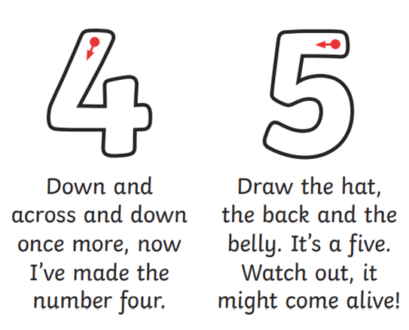    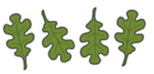   | Activities to support learning at home:  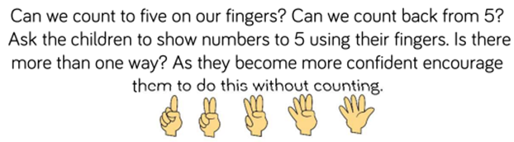  - Sing and explore counting songs and rhymes e.g. Five Little Ducks Went Swimming One Day, Five Currant Buns in a Baker’s Shop, Five Little Speckled Frogs etc. Encourage the children to use their finger or draw simple pictures to represent how the quantities are changing in different parts of the song.  - Do scavenger hunts to find up to 5 of particular items e.g. find 4 spoons  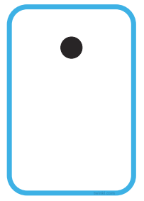  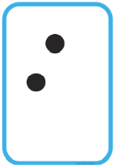  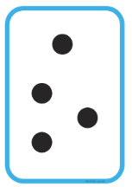  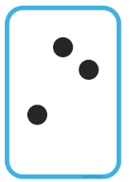  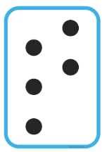  - Draw spots on Pieces of paper/paper plates to encourage the children to subitise (recognise and say the number being represented without the need to count) You could also use dice for this.  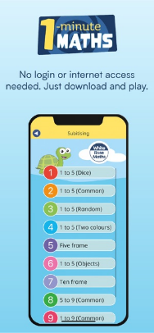  White Rose Maths have a brilliant free App called 1-minute Maths that has subitising games.

