

St Hugh of Lincoln Catholic Primary School - Reception Knowledge Organiser Autumn 2
Maths Topic: It’s Me 1, 2, 3! 3 (1 week)
Key information, Vocabulary and Questions:
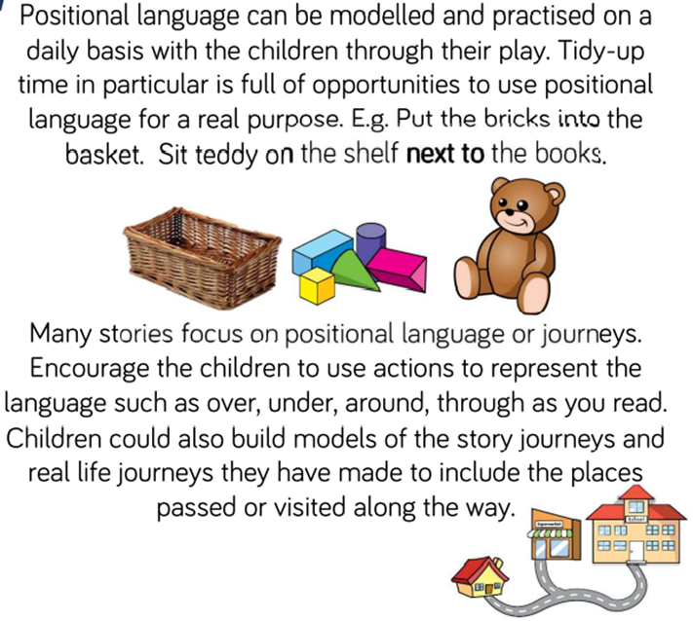 | Positional language  Activities to support learning at home:  - Hide an object/toy somewhere and give clues to find it e.g. teddy is in the washing machine or hunt for the object/toy then describe where it was found.  - Make and complete an obstacle course for a toy or a big one for yourself – give instructions for how to complete e.g. start in the chalk circle, go over the marbles, stand on the crate, crawl under the sheet, walk between the cone etc.  - On a walk, describe the position of places and objects in relation to others e.g. the shop is next to the café, the drain is under my feet, the birds fly over my head etc.  - Draw a plan of a room/small outdoor space and describe the position of objects e.g. the chair is next to the table, the vase is on the table etc.  - Play drawing games e.g. draw a teddy with a hat on his head standing under the sun, draw a girl standing on a rock throwing a ball over a wall etc.  - Duplo/Lego challenge: give instructions for where to put bricks: Put a yellow block on a red block, put a blue block under the yellow block etc.
  on | in | under | next to | over | between
  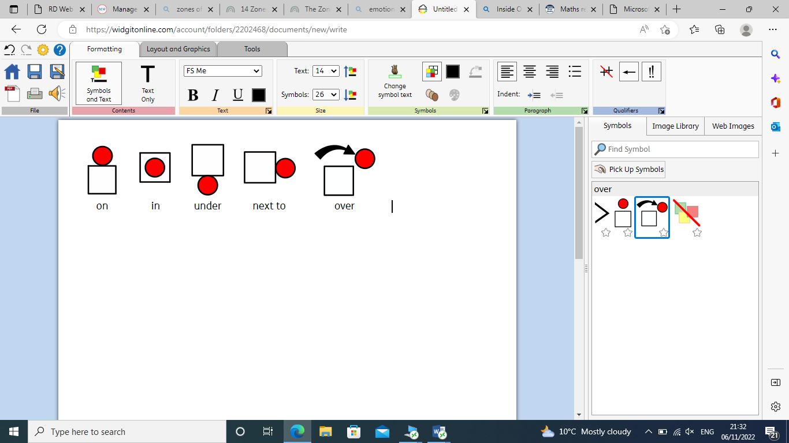 |  |  | 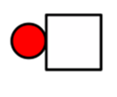 |  | 

