
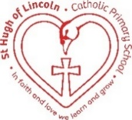
St Hugh of Lincoln Catholic Primary School - Reception Knowledge Organiser Autumn 2
Maths Topic: It’s Me 1, 2, 3! 2 (1 week)
Key information, Vocabulary and Questions:
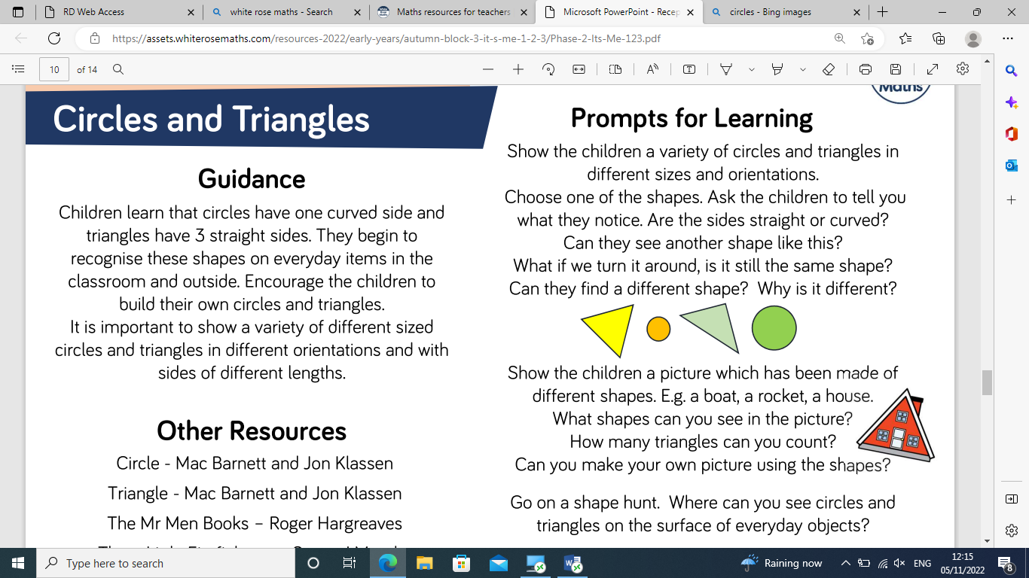 |     circle – a flat shape with one curved side  triangle – a flat shape with 3 straight sides  curved – not straight  straight – no bends or curves  Activities:  - Go on a shape hunt to find circles and triangles inside and outside.  - Make different sized triangles using sticks/straws/dried spaghetti – would it be easy to make circles with these materials? Why/why not?  - Use playdough to make circles and triangles – keep discussing the sides and naming them.  - Use triangles and circle pictures to make repeating patterns  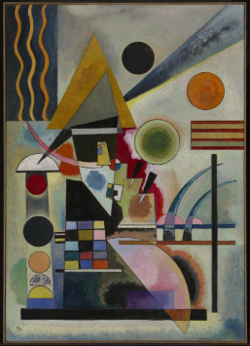  Wassily Kandinsky was a Russian artist who used shapes in many of his paintings. Explore some of his paintings. Can you see any triangles or circles? Do you like the painting? Why/why not? Which is your favourite? Explain why.  

