

St Hugh of Lincoln Catholic Primary School - Reception Knowledge Organiser Autumn 2
Topic: I wonder what materials are and how we can use them? 2 (1 week)
Focus Text and Vocabulary: | Key Topic Vocabulary and information:
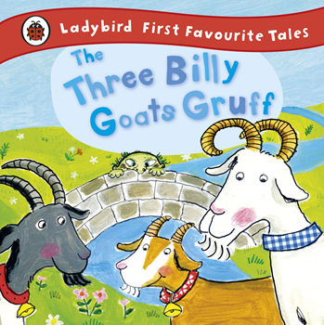  gnashed – snap teeth together  deafening – very, very loud | bridge – a structure used to get across something that otherwise would not be easy to cross.  sturdy – well built, not likely to fall down  Bridges can be built and used by pedestrians (people walking,) road vehicles or trains. Some are quite small and some can be very large!  They help make crossing safe or to make the journey shorter if there is something in the way (like a river, steep drop, rocky ground, road, railway etc.  They need to be very strong and sturdy so that they are safe and so that they do not break.  Bridges can be made of materials like wood, stone, metal and bricks  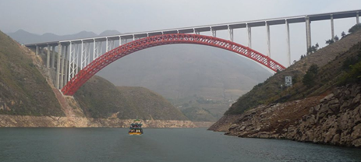  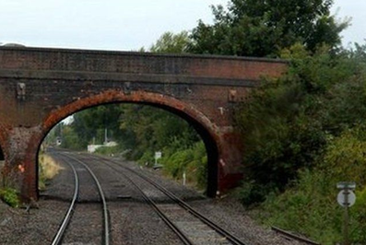  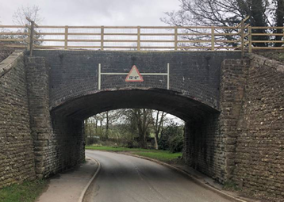  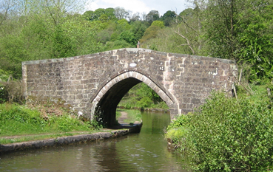  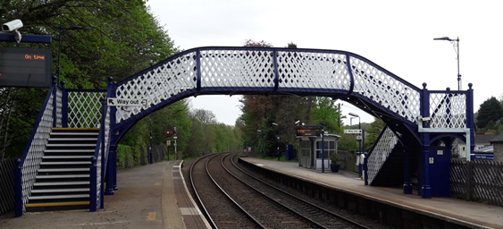  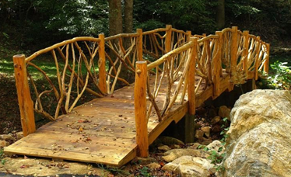
Activities to do with your child at home to support learning:
- Look for examples of different bridges online or in the local area. Why is the bridge there? Explore bridges that are made for humans, road vehicles, trains etc. What are the bridges made of? Why do you think those materials were chosen? Explain.
- Use junk modelling materials to make different model bridges. Draw a plan first to show what you want the bridge to look like. Predict which materials would make the strongest and sturdiest bridges. Think about how to join parts together. Could you use supporting pillars to make the bridge more sturdy? Which ones are the best? Explain why. What if you used a different material instead?
- Please feel free to send in photos of any model bridges (or send an electronic copy via the school office)

