

St Hugh of Lincoln Catholic Primary School - Reception Knowledge Organiser Autumn 2
Topic: I wonder what materials are and how we can use them? (1 week)
Focus Text and Vocabulary: | Key Topic Vocabulary and information:
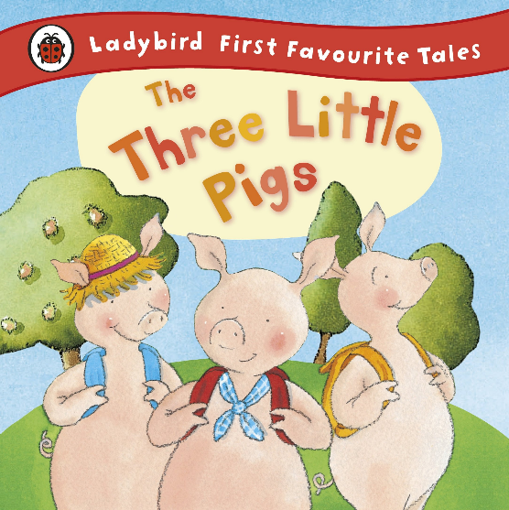  brave – to do something good even if it might be a bit dangerous or frightening  bold – likes adventure and not easily frightened
  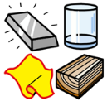  materials – what things are made of | 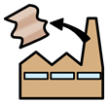  man-made – made by people
  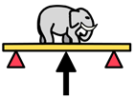  strong – not easily broken | 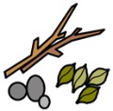  natural – made by nature, found in the natural world
  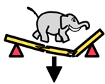  weak – not strong; easily broken | 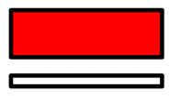  thin
  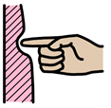  soft – can change shape when pushed | thick
  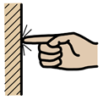  hard – shape will not be changed when pushed; not soft | 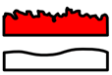  rough – feels bumpy when you touch it
   | smooth – does not feel bumpy when you touch it
  some materials
  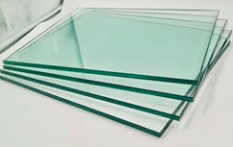
  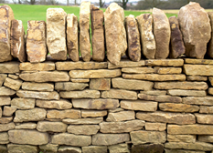
  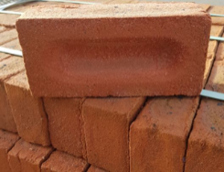
  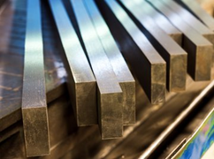
  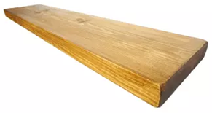
  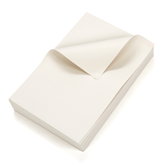
  wood metal bricks stone glass
  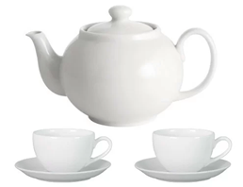
  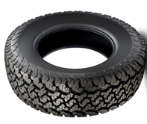
  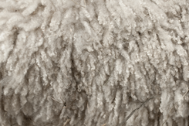
  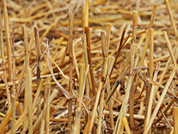
  wool straw rubber paper porcelain
Activities to do with your child at home to support learning:
- Ask children to go on a scavenger hunt around the home looking for objects made of different materials. Explore the objects together at the end and use some words to describe how hard/soft, rough/smooth, thick/thin they are.
- Show children a collection of objects. Can they sort them into groups of objects that are made of the same material?
- Use pairs of the following heading to sort a collection of objects:
hard/soft, rough/smooth, thick/thin
- Choose an object (like a spoon/bowl/key etc.) Discuss what it would be like if it was made of a different material. What problems might there be?
- Explore the outside of your home. What materials have been used to build different parts? Why do you think those objects have been chosen for the job?
- Can you find any objects that are made of more than one material? Why do you think that is?
- Ask the children what material they think would be best to make a bed, car, saucepan, house etc. and explain their reasons why.

