
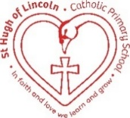
St Hugh of Lincoln Catholic Primary School - Reception Knowledge Organiser Autumn 2
Topic: I wonder what things were like in the past? 2 (1 week)
Focus Text and Vocabulary: | Key Topic Vocabulary and information:
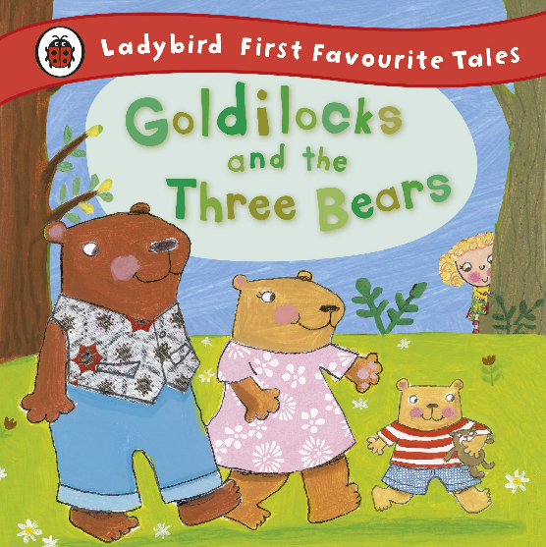  nosy – being too interested in other people or things  sobbed – cried loudly | old – from back in the past  modern – new, from our time now  workshop – a room where people work to make things  factory – a building where machines are used to make things
  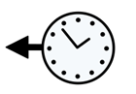  old | 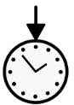  modern
  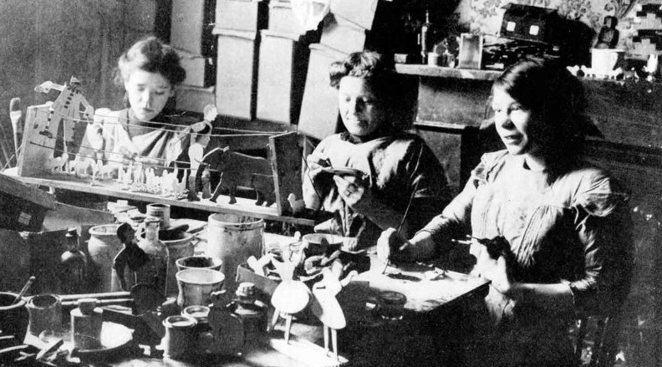 | 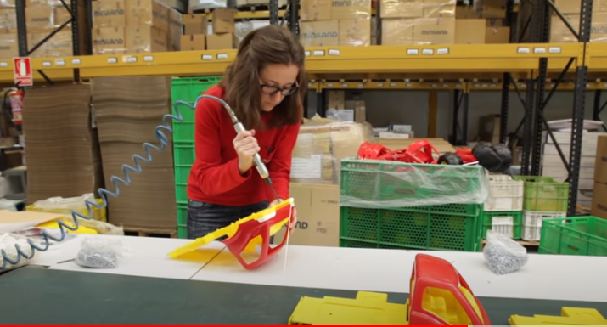
  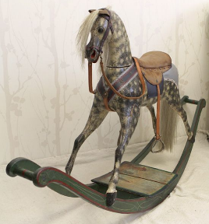  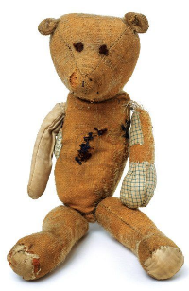  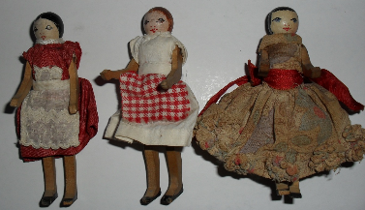  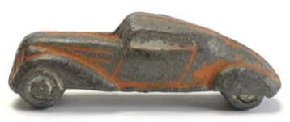  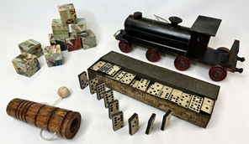 | 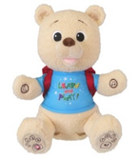  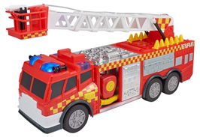  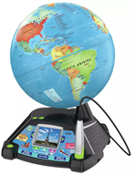  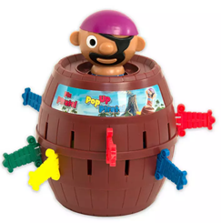  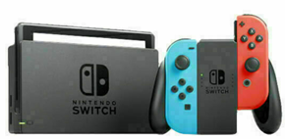  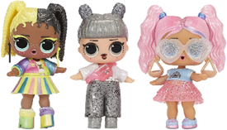
Activities to do with your child at home to support learning:
- Explore online collections of old and modern toys on websites like:
https://collections.vam.ac.uk/search/?id_category=THES48967 – V&A Museum of Childhood
Collections search | Hampshire Cultural Trust Online Collections (hampshireculture.org.uk) – Mr Simpson’s Teddy Bear Museum at Milestones Museum - Which are your favourite? Why? Which do you think are the oldest/most modern? Why?
- Explore a modern toy from home. How/where do you think it was made? What materials is it made from?
- Talk about toys that were different when you were a child! Even better if you still have any or photos of any.

