
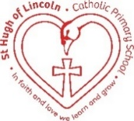
St Hugh of Lincoln Catholic Primary School - Reception Knowledge Organiser Autumn 2
Topic: I wonder what things were like in the past? (1 week)
Focus Text and Vocabulary: | Key Topic Vocabulary and information:
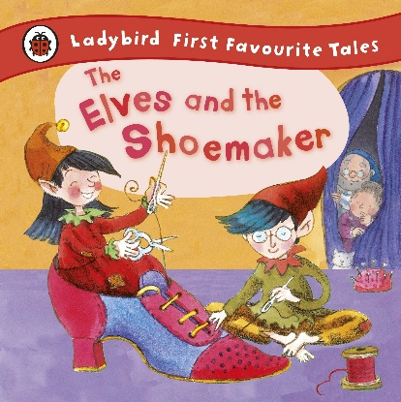  surprise – something you didn’t think would happen  grateful – thankful for | old – from back in the past  modern – new, from our time now  workshop – a room where people work to make things  factory – a building where machines are used to make things
  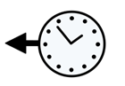  old | 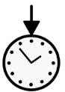  modern
  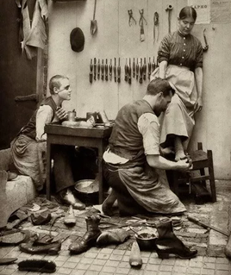 | 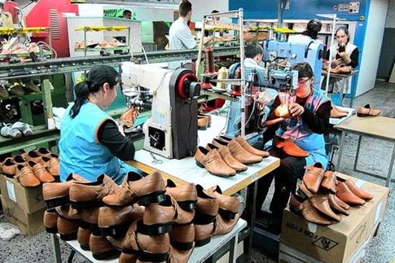
  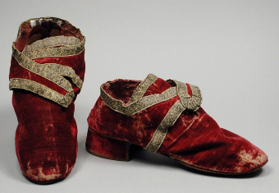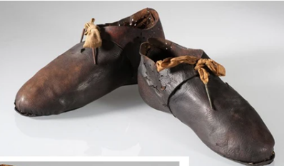  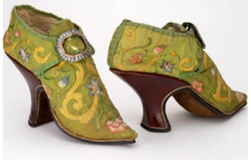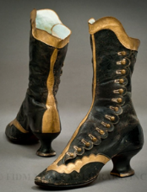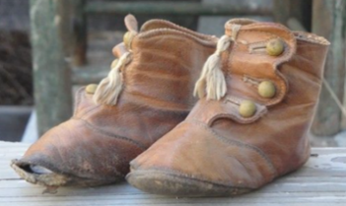 | 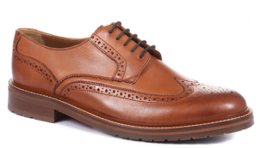  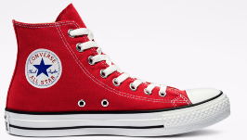  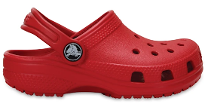  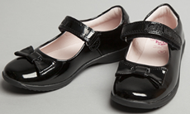  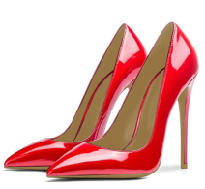  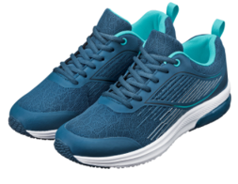
Activities to do with your child at home to support learning:
- Read a selection of traditional tales (those set partly inside homes/buildings are good e.g. Jack and the Beanstalk, Cinderella, The Emperor’s New Clothes, Dick Whittington, The Town Mouse and the Country Mouse etc.) Look for clues that that the story is set in the past. Explore clothes, transport, homes etc.
- Explore the Victoria and Albert Museum’s online collection of old and modern shoes from all over the world at https://www.vam.ac.uk/collections/shoes Which are your favourite? Why? Which do you think are the oldest/most modern? Why?
- Explore photos of parents and grandparents. Talk about how fashions have changed over time.
- Explore a pair of shoes from home. How do you think they were put together? Can you see any stitches or joins? What materials were used to make the shoes?
- Draw a design your dream pair of shoes!
- Talk about familiar objects around the home that were different when you were a child! Even better if you have or can find photos on the internet e.g. telephones, computers, televisions, VCR/cassette players (I think that compact discs are even classed as ‘old’ technology now!!!)

