

St Hugh of Lincoln Catholic Primary School - Reception Knowledge Organiser Autumn 2
Topic: I wonder what emotions are and how they affect us? (2 weeks)
Focus Text and Vocabulary: | Key Topic Vocabulary and information:
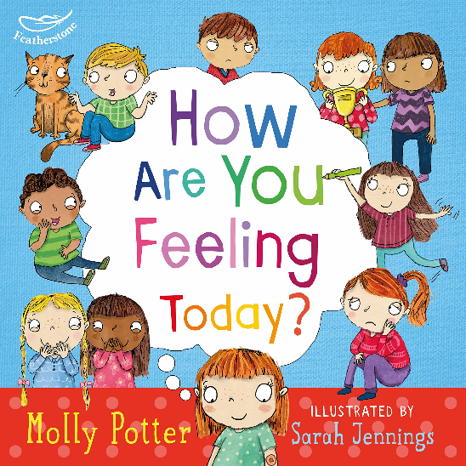  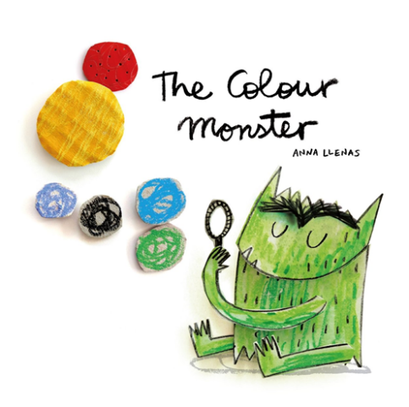  ignore – take no notice of, don’t think about at all  weak – not strong | emotions – the feelings we have inside  affect – cause a change in how we feel and behave  manage – take control of  It is normal for people to feel different emotions. We will feel different emotions at different times. Some emotions are weak and are easy for us to ignore. Some emotions are strong and they can affect the way we behave. Some strong emotions can make us want to hurt ourselves (with our actions or words) or they might make us want to break things. If we feel these bad emotions then we need to learn ways to manage our emotions. It is ok to have strong emotions but we need to find ways to help make those feelings smaller.  When we feel these emotions, we might feel good:  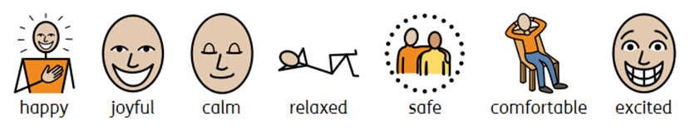  When we feel these emotions, we might feel bad:  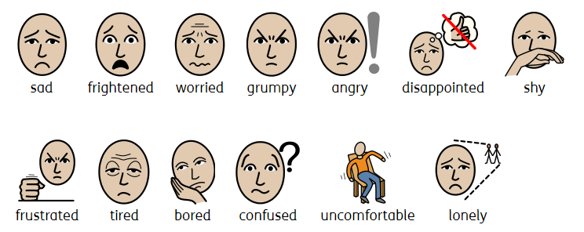
Activities to do with your child at home to support learning:
- Talk to different members of the family about times that they have felt strong emotions. How did it feel? What did they do when they felt that way?
- Make a plan for what to do when you are feeling strong emotions to help them get smaller. Maybe there is a safe/comfortable place in the house you could go to (some children may prefer a small, enclosed space like a tent or a den) with a ‘tool kit’ of objects that may help to make that emotion get smaller. This could include:
* objects with favourite smells (vanilla pod, pot of scented playdough, essential oils on a piece of cloth, pillow spray etc.)
* drawing/colouring/scribbling materials
* objects to scrunch and squeeze like a pillow/cushion, bubble wrap, playdough, fidget toys
* objects to cuddle and provide comfort like a favourite cuddly toy/blanket
* ear defenders/earmuffs
* objects that produce light like a torch, fibre optic lamp, lava lamp
* a favourite book to read or music to listen to
(some children may prefer to do ‘big’ actions like running, jumping, crawling, pushing against a wall or the floor – set some guidelines together as to how and where they can do this safely)
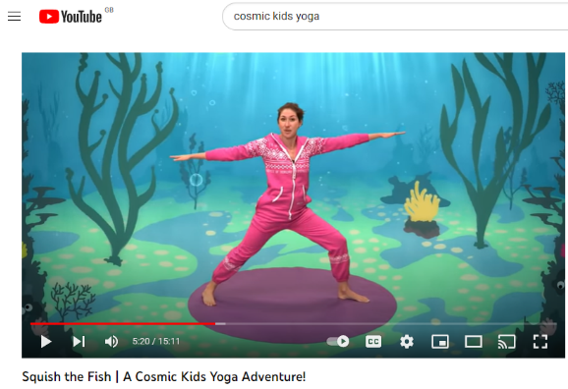
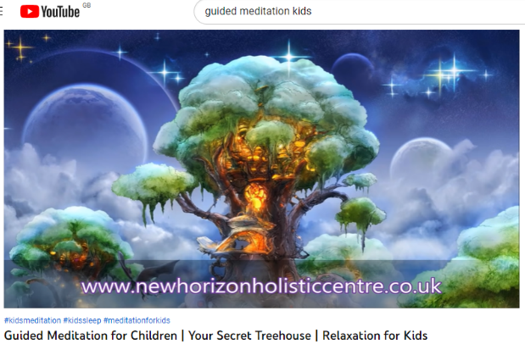
- Do some guided meditation/yoga together to help maintain positive physical, emotional and mental wellbeing:

- Go outdoors to enjoy nature! Combine it with physical activity and exercise like running, walking, cycling, scooting, climbing etc.

