

St Hugh of Lincoln Catholic Primary School - Reception Knowledge Organiser Autumn 1
Maths Topic: It’s Me 1, 2, 3! 1 (1 week)
Key information, Vocabulary and Questions:
Subitising – recognising the number being represented without needing to count. You can practise this with cards/paper plates displaying different numbers of dots:  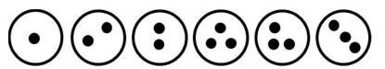  How can you show 1, 2 or 3? Can you show it a different way?  Which is more? How do you know?  How many would you have if you had 1 more? Prove it! | Representing 1, 2, 3 Activities:  - Use objects at home to represent 1, 2 and 3 e.g. bowls containing 1, 2 and 3 loose parts (conkers, pasta shapes, beads etc.), 1, 2 and 3 objects on 5 frames, make towers of 1, 2 and 3 blocks  - Match the numerals 1, 2 and 3 to groups of objects.  - Ask children to draw/paint 1, 2 and 3 objects/shapes.  - Use playdough to make 1, 2 and 3 balls, sausage shapes etc.  - Thread 1, 2 and 3 beads/pasta shapes onto string/spaghetti/pipe cleaners.
Form the numerals 1, 2 and 3:  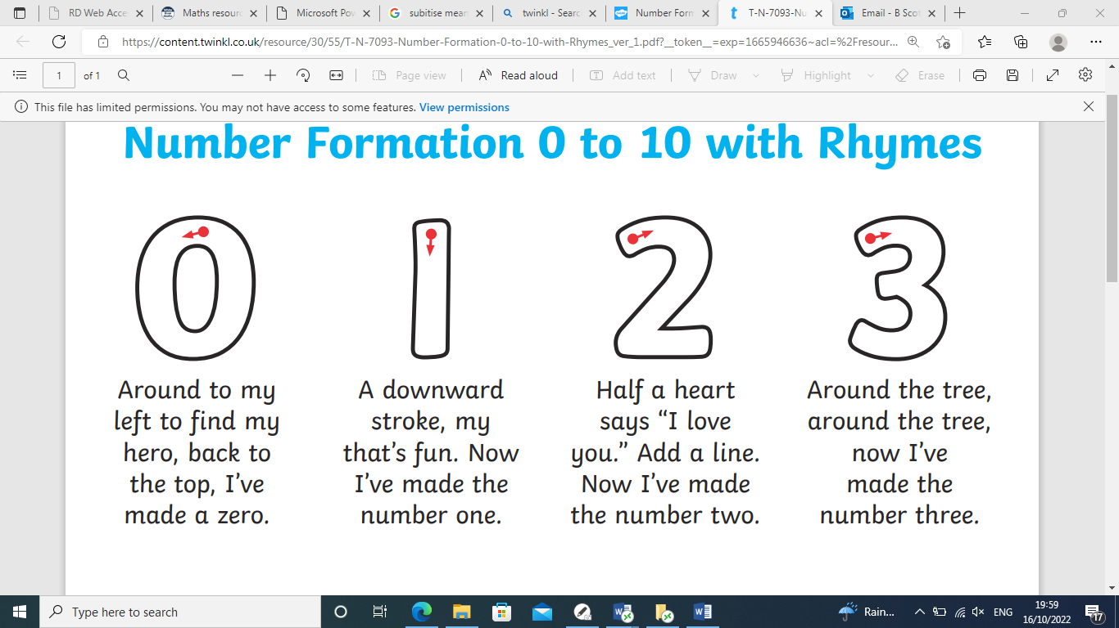 | 

