

St Hugh of Lincoln Catholic Primary School - Reception Knowledge Organiser Autumn 1
Maths Topic: Just Like Me 3 (1 week)
Key information, Vocabulary and Questions:
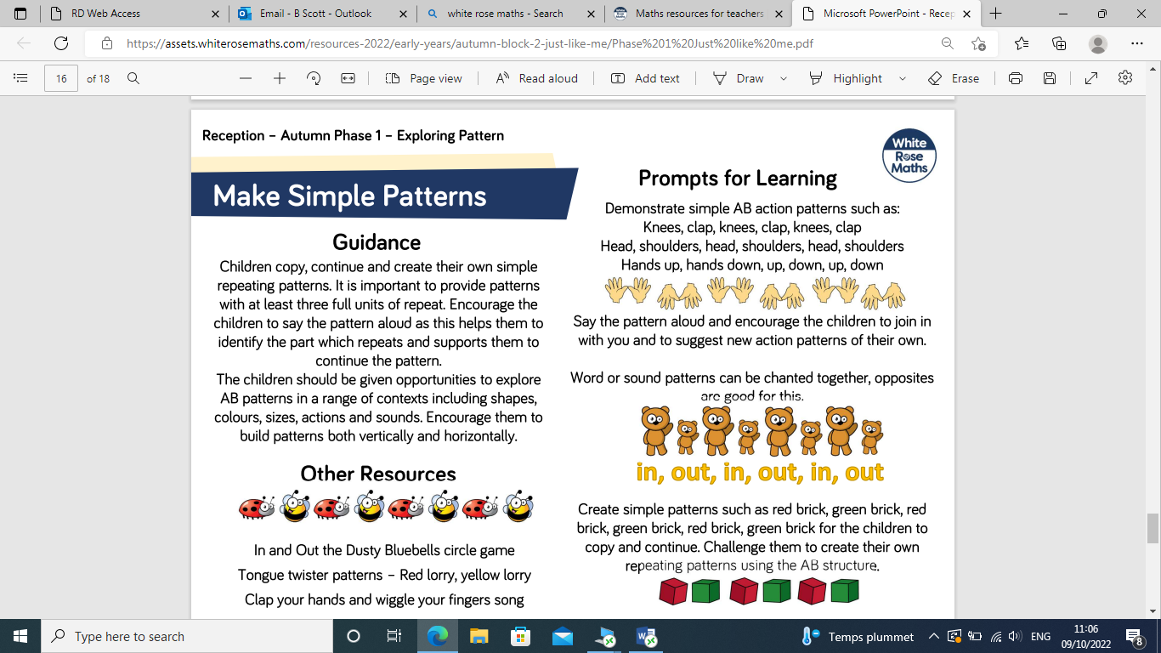  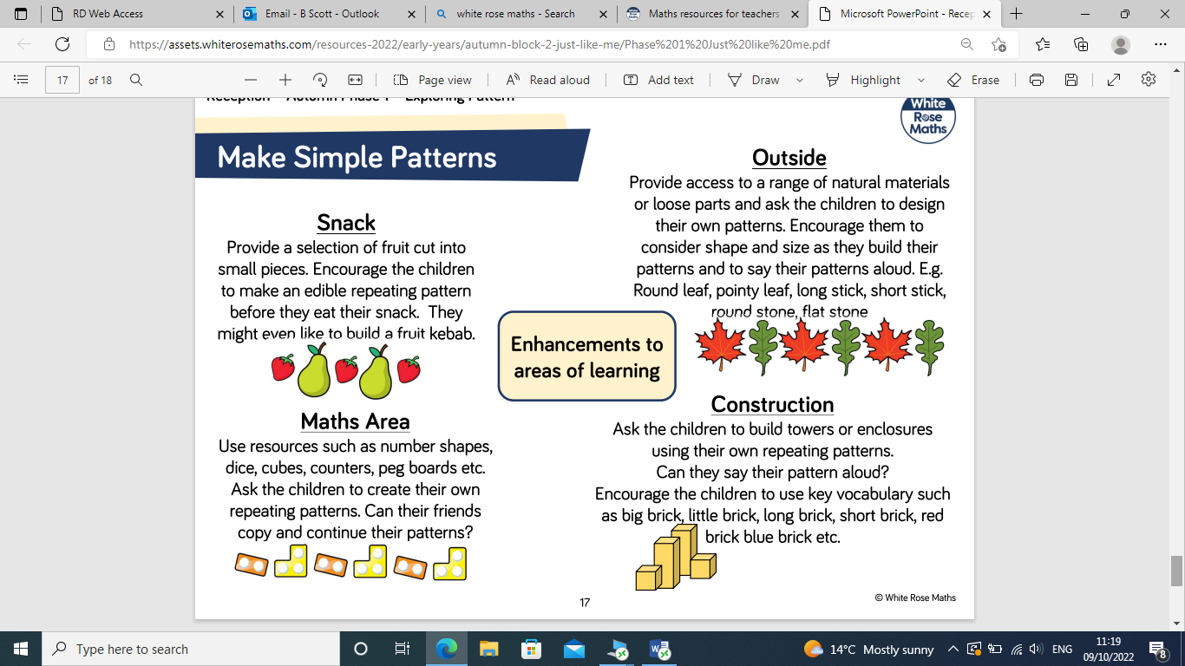  Can you carry on my repeating pattern?  What will come next? How do you know?  What have I hidden/taken away from the repeating pattern? How do you know?  Can you describe this pattern to me?  Talk about the pattern I/you have made.  Can you spot any mistakes in this pattern? How do you know? Can you fix it? | Repeating Pattern Activities:  - Use loose parts (buttons, beads, conkers, acorns, pasta shapes, blocks, leaves etc.) to make repeating patterns. Make a pattern for your child and ask them to describe it. Can they carry it on? If you hide part of it, can they tell you what part is hidden and how they know?  - Use construction blocks like Duplo and Lego to make repeating colour pattern towers and discuss as above.  - Ask children to make their own repeating patterns as above.  - When children are confident enough, you could explore different pattern structures:  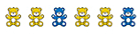  AAB:  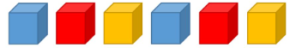  ABC:

