

St Hugh of Lincoln Catholic Primary School - Reception Knowledge Organiser Autumn 1
Maths Topic: Just Like Me 2 (1 week)
Key information, Vocabulary and Questions:

 | Comparing Activities:  - Each take a handful of loose parts (buttons, beads, conkers, acorns, pasta shapes etc.) and count to see who has more/the most.  - Set the table together, has everyone got an equal amount of cutlery? Serve meals/snacks together. Who has an even number of X? Who has more/the most/fewer/less/the least?  - Use chalk to mark each other’s heights on an outside wall – who is taller/tallest/shorter/ shortest?  Who has more/the most? How do you know?  Who has less/fewer/the least? How do you know?  Which is taller/the tallest? How do you know?  Which is shorter/the shortest? How do you know?  - Explore balls of dough. Ate the smallest balls the heaviest or the lightest? How do you know?  - Compare a selection of fruits/vegetables. Which do you think will be the lightest? How can we check?  - Explore two containers of different sizes (e.g. yogurt pot and a mug.) If we fill each with tablespoons of flour/sugar/sand/water, which will hold the most?
  compare – look at 2 or more things and think about the things that are the same or similar about them and the things that are different | 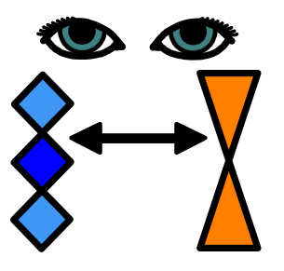
  equal – the same amount | 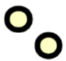    =  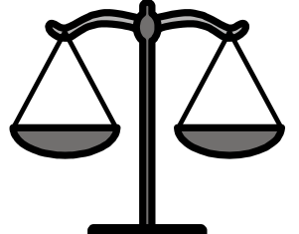
  more – a greater number or amount  most – the greatest amount | 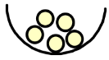  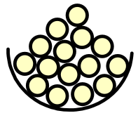
  less – a smaller number or amount  fewer – less objects  least – the smallest amount | 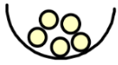  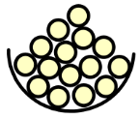
  taller – has more height than another  tallest – the most tall | 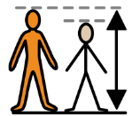  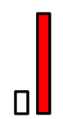
  shorter – has less height than another  shortest – the most short | 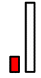  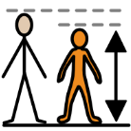
  heavy – has a lot of mass  heavier – has more mass  heaviest – has the most mass | 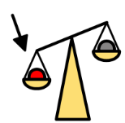  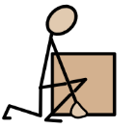
  light – does not have much mass  lighter – has less mass  lightest – has the least amount of mass | 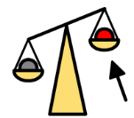  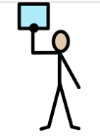
We can use 5 frames to help us count and compare amounts. Please find some 5 frames included to cut out and use at home.



