

St Hugh of Lincoln Catholic Primary School - Reception Knowledge Organiser Autumn 1
Maths Topic: Just Like Me 1 (1 week)
Key information, Vocabulary and Questions:
Match – put objects that are the same together  Matching pairs – 2 pictures or objects that are the same  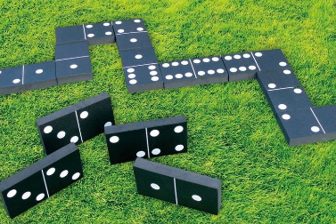  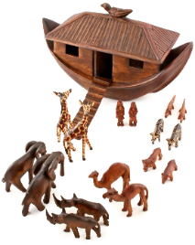  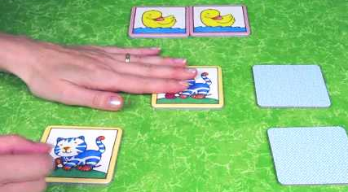  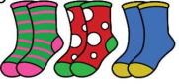  Can you find one exactly like mine?  How do you know it is the same?  Can you find one that is different to mine?  Why is this one not like mine? | Matching Activities:  - Sort a collection of socks, gloves, shoes into matching pairs  - Play matching card games like Snap  - Play dominoes to recognise matching numbers  - Use construction sets like Duplo/ Lego to build 2 identical towers/models
sort – make groups of things that are similar or the same  Often, we can sort things in different ways e.g. by colour, size, shape etc.  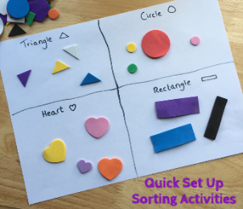  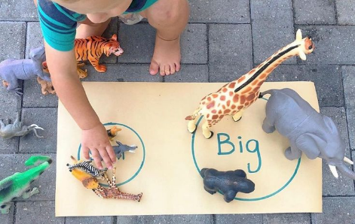  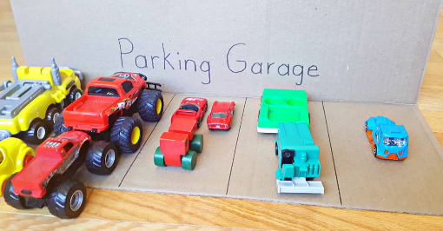  What is the same or similar about any of these?  Can you put the objects that are the same or similar together to make groups?  Can you sort them in a different way? | Sorting Activities:  - Provide a collection of loose parts like buttons, beads, shells, leaves, toy animals, toy vehicles etc. Encourage the children to sort the items one way (e.g. by colour) then explore different ways they can be sorted (e.g. by size)

