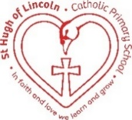

St Hugh of Lincoln Catholic Primary School - Reception Knowledge Organiser Autumn 1
Topic: I wonder how people’s lives can be different to ours? 2 of 2 (1 week)
Focus Text and Vocabulary: | Key Topic Vocabulary and information:
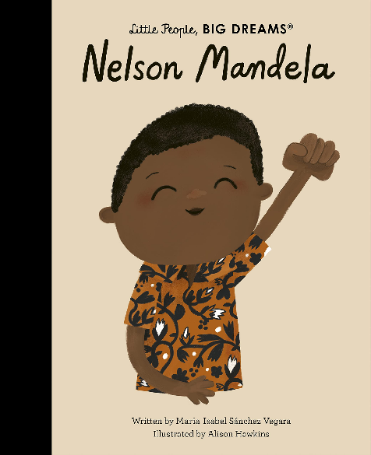  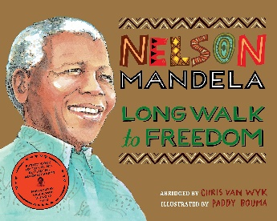  education – learning  justice – fair and right  release – set free | 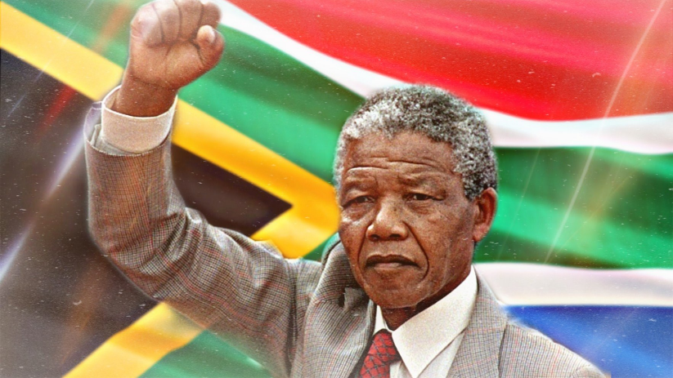  Nelson Mandela – A man from the past who was born in and lived in South Africa. When he was born, more than 100 years ago, life was not fair for people with black skin. He believed that everyone should be treated the same, no matter what colour their skin was, so he worked hard to try and change things. The leaders of South Africa did not like this and Nelson Mandela was sent to prison for 27 years! After he was released from prison (when Miss Scott was a little girl) Nelson Mandela became the President (leader) of South Africa and made sure that life was fair for black and white people who lived there.  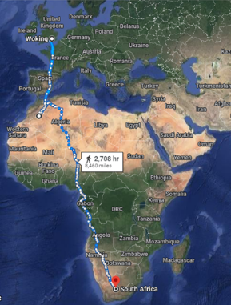  South Africa – a country in Africa where Nelson Mandela was born and raised.  Equal rights – everybody should be treated the same and fairly
Activities to do with your child at home to support learning:
- Explore times when you or your child feel like you were not treated fairly – how did that make you feel at the time?
- Explore what you could do if you felt that someone wasn’t being treated fairly.
- Family members who have memories of Nelson Mandela in their lifetime could share what they remember about him and his life. Share photographs of the family member at different points in Nelson Mandela’s lifetime to help the children get a sense of his position in history.
- Talk about what Nelson Mandela means to you and why you think he is so important.
- If you know anyone who has spent time in South Africa within Nelson Mandela’s lifetime or since his death, talk about what it was/is like there and how important he was in the country’s history.
- Explore the lives of inspirational people within your own family and how they made a difference.
- Explore the lives of other pioneering figures within the history of equal rights campaigning including people like Martin Luther King Jr, Rosa Parks, Mahatma Gandhi, Malala Yousafzai, etc. (The Little People, Big Dreams collection of children’s books are great for this and should be available from your local library)

