

St Hugh of Lincoln Catholic Primary School - Reception Knowledge Organiser Autumn 1
Topic: I wonder how people’s lives can be different to ours? 1 of 2 (2 weeks)
Focus Text and Vocabulary: | Key Topic Vocabulary and information:
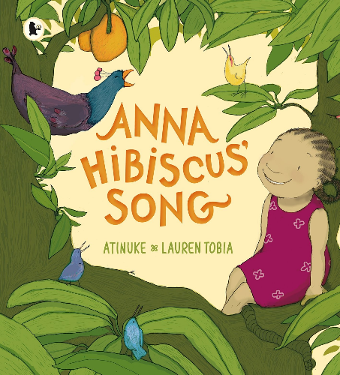  cool – not too warm  pounding – hitting (the yams) over and over again  explode – burst, blow up  Search: anna hibiscus song full story - YouTube | 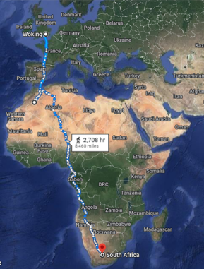  countries – areas of land that have their own rulers. Countries can be different sizes. Some can be very large and others can be quite small. The country we live in is the United Kingdom.  Africa – a large group of many countries  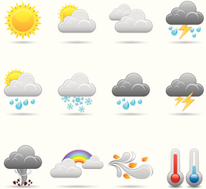  weather – what it is like outside. Is it hot, warm, cool or cold? What can you see in the sky? Is there sunshine, white/grey/black clouds? Is there anything coming down from the sky like rain, hailstones, sleet or snow? Can you hear/feel wind/thunder/lightning?  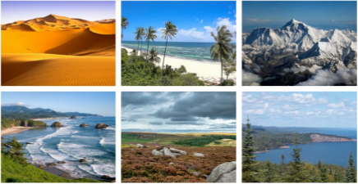  landscape – what the land is like. What plants are growing there? Is it flat or are there hills or mountains? What is on the ground? Is there sand, soil, grass, or rocks on the ground?  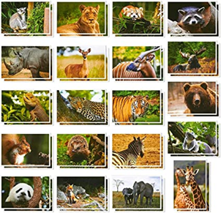  wildlife – the animals that live in a place.  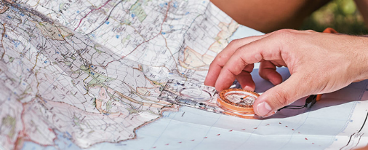  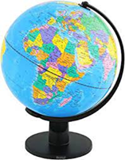  maps – pictures of places that show where a place is and what things we can find there. We can use maps to help us find our way somewhere.  globe – a map of our planet on a ball.
Activities to do with your child at home to support learning:
- Explore and talk about the local area around where you live. What are some of the main trees/plants growing there? What wildlife can you spot? What is the weather like?
- Use paper or electronic maps to explore short, familiar routes with your child. Can you find familiar landmarks (e.g. school, supermarket, sport’s field etc.) on local maps?
- Encourage your child to draw simple maps of short, familiar routes e.g. to school.
- Explore pictures/video clips online of the United Kingdom. Look at and discuss some of the different landscapes found there e.g. cities, rural villages, coasts, mountains etc. What do you think the weather is like there? What wildlife can you see?
- Explore pictures/video clips online of places in Africa. Look at and discuss some of the different landscapes found there e.g. cities, rural villages, coasts, mountains etc. What do you think the weather is like there? What wildlife can you see?
- If you know anyone who has visited any part of Africa, ask them if they have any photos about where they visited and what it was like there that they could share with you. Do they have any photos they could share?
- Talk about any trips you have made together to different parts of the country/world. What things were different there? What things were the same or similar?
- Use maps, atlases and globes at home to explore the United Kingdom and its position in the world in relation to other countries you have visited/have links to. (These could be accessed online or via local libraries which are free to join!)
- Discuss which parts of Africa you would like to visit the most and why.

