

St Hugh of Lincoln Catholic Primary School - Reception Knowledge Organiser Autumn 1
Topic: I wonder who helps us? (2 weeks)
Focus Text and Vocabulary: | Key information:
heroes – people who have done something great to help others  save – to stop someone or something from getting hurt or ruined  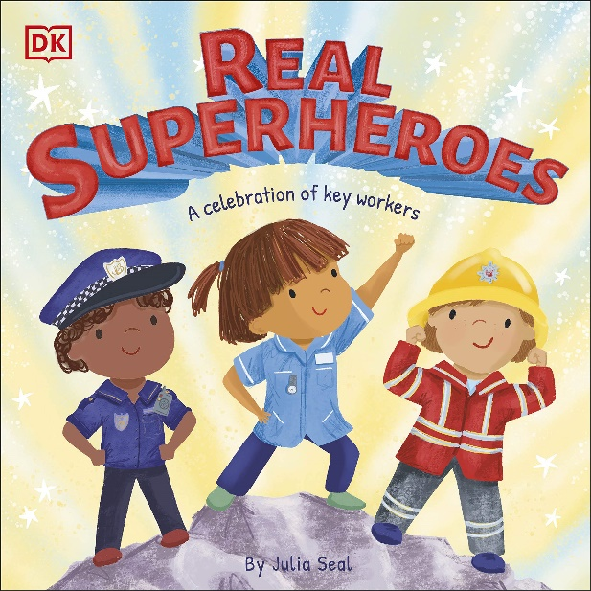 | 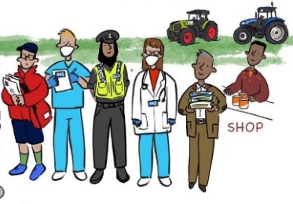  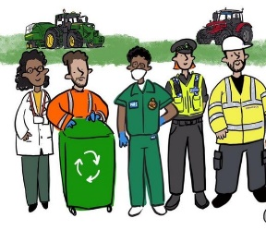  Key Workers  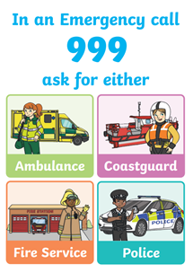  - Many people have jobs that are very important because they help us in our lives. We call them key workers, or essential workers, because we need them very much. It is important that we understand how important their jobs are and we should thank them when we can.  - Key workers include:  Doctors, nurses, paramedics, fire fighters, police officers, pharmacists, postal workers, teachers and school staff, nursery staff, shop workers, refuse collectors, cleaners, carers, coastguard, delivery drivers, farmers, lollipop men and women, bus drivers, train drivers and many, many more!  - In an emergency, if someone is badly hurt, very unwell, trapped or in some other danger, you may need the police, fire brigade, paramedics or coastguard to come and help. To get help from any of these people, dial 999. You will need to say what help you need and where you are. You must NEVER call 999 unless it is a real emergency.
Key Topic Vocabulary:

safe – not in danger

emergency – a dangerous situation where you need help fast

rescue – to help someone or something get out of danger or out of a bad situation
Activities to do with your child at home to support learning:
- Reflect on your day – talk about which key workers have provided a service for you today.
- Do you know any key workers? Talk about what they do and ask them some questions to find out more about their job.
- Think of ways that you can show appreciation to key workers and thank them for the job they do.
- Think about one key worker job and imagine what it would be like if no one did that job. What problems you might you have?
- Draw and label different key workers.
- Dress up as different key workers and role play what their day might be like.
- Look out for key workers and their vehicles on the roads and in your local area.

Safety:
- Talk about how to cross the road safely and practise together.
- Make a plan of what to do if there was a fire at home.
- Talk about what to do in an emergency and how to call 999. Do the children know their address in case there is an emergency at home and they need to call for help? Do they know how to use your home or mobile phone in case of emergency?

