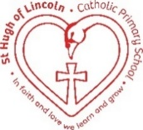

St Hugh of Lincoln Catholic Primary School - Reception Knowledge Organiser Autumn 1
Topic: I wonder what makes me so special? 2 of 2 (1 week)
Focus Text and Vocabulary: | Key information:
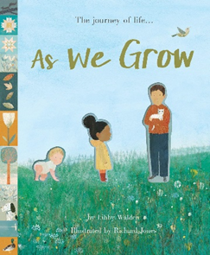  transforming – changing  precious – very special and loved  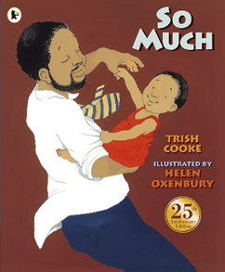  scrunch – squeeze together  cosy – warm and comfortable | - When we were born, we were tiny babies. We couldn’t do much for ourselves.  - Over time, we have grown bigger and we have learned to do more things ourselves.  - Throughout our lives, we will keep changing as we grow older.  - Families can be different for different people.  - Some families are very big and some can be very small.  - Some people have family in different homes that they may stay with at different times.  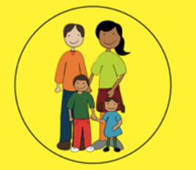  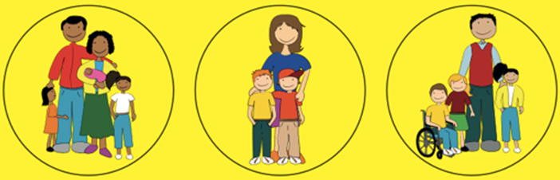  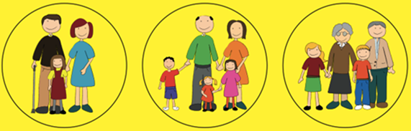
Key Topic Vocabulary:

grow – to get bigger

change – start to look different

family – the most important people in our lives. We may live with them and they take care of us.

relatives – the people who make up our family. They could be:
Mummy, Daddy, Nanny, Grandad, Grandma, brothers, sisters, aunties, uncles, cousins

Activities to do with your child at home to support learning:
- Explore photographs of when members of the family were babies. Who is who? How have they changed?
- Talk about the things you can do now that you couldn’t do when you were a baby/toddler.
- Share photographs of a family member at different ages – can you put them in the right order?
- Make a list of the members of the family in age order starting from the eldest to the youngest. Discuss how the oldest member of the family was born the longest time ago.
- Make a family tree together.
- Talk about your child’s relatives.
- Talk about times when the family have come together for celebrations.
- Talk about ways that life might have been different for you when you were your child’s age.
- Plan ways that you can let family members know how much you love them.

