
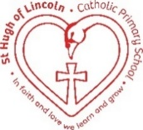
St Hugh of Lincoln Catholic Primary School - Reception Knowledge Organiser Autumn 1
Topic: I wonder what makes me so special? 1 of 2 (2 weeks)
Focus Text and Vocabulary: | Key information:
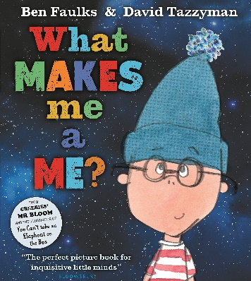  similar – alike but not exactly the same  different – not the same  special – very important | 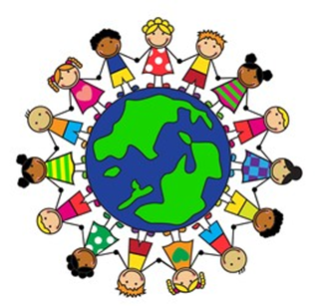  - We are all very special people.  - We are individuals with our own ideas and voices.  - There is no one else who looks exactly the same as us – we are all beautiful! It would be very boring if we all looked the same!  - We should be proud of the things that make us who we are!  - We may like different things to our friends and that is ok.  - We should celebrate the things that are different about ourselves.  - We should always be respectful about the ways that people might be different to us.
Key Topic Vocabulary:

individual – a person with their own ideas

valuable – very special and precious

unique – being the only one like that, no other one is the same

talent – something a person does really well

proud – feeling very happy about something you have done or can do

respectful – kind, treating others like you want to be treated yourself

Activities to do at home to support learning:
- Discuss some of the ways that members of your family are similar/different. Think about what you look like, the things you like and the things you are good at.
- As a family, talk about the things you love most about yourselves and each other.
- Talk about the things that make you feel proud of yourself and proud of others.
- Talk about how to be respectful to each other in your home.
- Share some of your talents at home!
- Try out some new hobbies together!

